# First Lab Exam. Model 4

November 2015

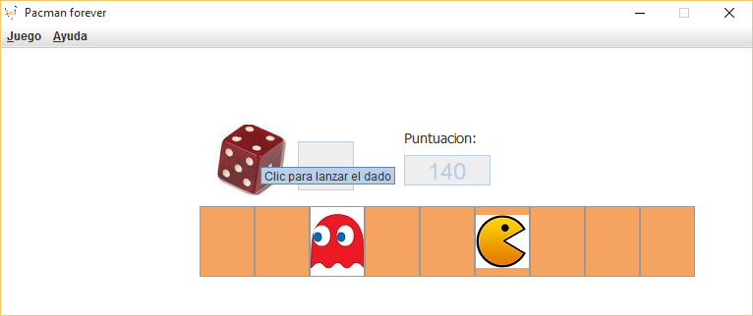

Name and Surname:

National ID (DNI or Passport):

The goal of this exam is to develop a simplified version of the Pacman game, in which the player must move the piece all along the board until the last position. The board must have **9 cells**, being the first the starting point and the last the goal. Each cell gives **90** points that the user will earn every time his/her piece falls in one of these cells. The movement will be calculated with a dice that generates random numbers from **1 to 3**. When the user reaches the last cell, the game is over.

Complete/Modify the given project to reach the described goal. For that, the following points must be developed:

1. Complete the board using the layout that suits better among the ones we used in the labs, and the elements you require for the game.
2. Add the required method/methods and complete the functionality of the application, including the showing of user’s score after each movement.
3. Modify as needed interface attributes and components in order to increase its usability, following the rules and recommendations given all along the course.
4. Program the actionPerformed event handler for the dice by means of a class named “AccionDado” that should invoke the method “tirar” of VentanaPrincipal class.
5. Add a menu with four elements (New Game, Exit, and About) with the appropriate organization. The “About” dialog must show the name and ID of the student.
6. Modify the game in order to create a Ghost that can appear in any cell but in the first or the last. The ghost will be automatically moved randomly after the pacman moves. If the ghost appears in the same cell where pacman is, the game is over.
7. Allow users to customize the number of cells of the game, which can be between 7 and 10.

NOTES:

1. **Check that the *Lazy* code generation strategy is selected before starting the exam.**
2. Those methods that are commented must be completed before using them in order to avoid compilation errors.
3. **Points 1 and 2** are the minimum required to have the exam evaluated. Implementing points 1 to 6 can reach a mark up to 9 points. Point 7 implementation can raise the mark up to the 10 points.

# Exam delivery

Rename the name of the project from eclipse with student’s dni. The student will create a zip file (named with his/her dni) with the Project folder and delivery it through the virtual campus

Accessing to the delivered task in the virtual campus after the exam **is not allowed** and will be considered **copy**. Notice that the activity in the virtual campus is **monitored.**